**Tournament**

Renis Hila - 4506626

Class: S2-CB06

Git Repository: https://git.fhict.nl/I484075/semester2-tournaments.git

**February 2023**

**Contents**

**1.** **Description** 3

**2.** **Site Map** 4

**3.** **Wireframes** 5

# **Description**

The goal of this project is to develop a comprehensive platform for managing a variety of tournaments, from football to video games. The application will be accessible via both web and desktop, and will be available for use by both administrators and users.

The administrator will have the ability to create teams, tournaments, matches, and add players, as well as delete inappropriate tournaments. They will also have the ability to manage user accounts, such as resetting passwords and removing accounts for inappropriate behaviour.

Users will need to create an account and log in to create tournaments and matches. However, they will not have the ability to create teams, add players, or delete other user accounts, as these tasks are reserved for the administrator.

The application will consist of several key features:

1. Login
2. Account Creation
3. Tournament (accessible by both admin and user)
4. Match (accessible by both admin and user)
5. Team (accessible by administrator only)
6. Player (accessible by administrator only)
7. User (accessible by administrator only)
8. My Account (accessible by both admin and user)
9. Logout

Overall, the tournament management application aims to simplify the process of creating and managing tournaments for all involved parties, providing a centralized platform for administrators and users to collaborate and stay up-to-date on tournament progress.

# **Site Map**

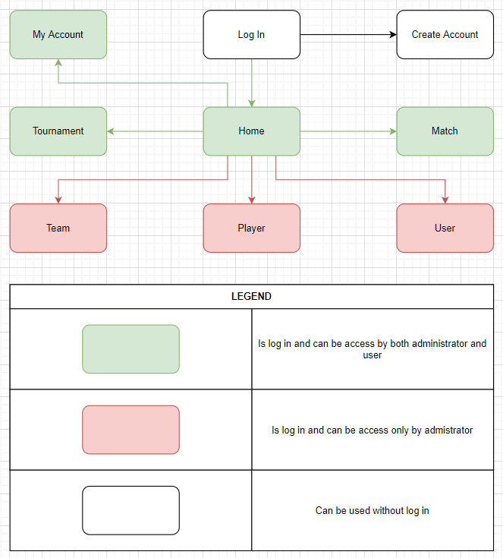

# **Wireframes**

